Transit gateway

VPC peering is used to connect two VPCs so they can communicate with each other easily. But while working with a large number of VPC connectivity it becomes complicated, as the number of VPCs increases. The network become complex.
For example, if you want to connect 5 VPCs directly, you would need to create over 10 individual peering connections. Managing and maintaining all these links can be difficult and confusing.
To overcome this disadvantage we uses the AWS Transit gateway.
AWS Transit gateway:
AWS Transit Gateway is a fully managed service by AWS that connects VPCs and on-premises networks through a centralized hub. This design reduces the need for complex peering relationships (like VPC peering) and simplifies management. Think of it as a central router that simplifies network architecture and management, especially in complex, distributed environments.
Without a Transit Gateway, if you have multiple VPCs that need to communicate with each other, you would typically set up a mesh of VPC peering connections. This becomes incredibly complex and hard to manage as the number of VPCs grows (e.g., for N VPCs, you need N*(N-1)/2 peering connections).
Transit Gateway acts as a central hub. Each VPC (or on-premises network) connects only to the Transit Gateway, simplifying the routing table management and reducing the number of connections.

Features:
- Centralized Connectivity Hub: Acts as a central point for connecting thousands of VPCs and on-premises networks.
- Route Tables: Each Transit Gateway has its own route tables. You can associate VPC attachments and VPN attachments with specific route tables to control traffic flow and implement network segmentation.
- Attachment Types:
- VPC Attachments: Connects your Amazon VPCs to the Transit Gateway.
- VPN Attachments: Connects your on-premises networks to the Transit Gateway via IPsec VPN/VPG tunnels.
- Direct Connect Gateway Attachments: Connects your Direct Connect Gateways to the Transit Gateway, allowing your on-premises network to access multiple VPCs through a single Direct Connect connection.
- Peering Attachments: Allows you to peer two Transit Gateways in different AWS regions, enabling inter-region connectivity.
- Traffic Segmentation: Use separate route tables and associations to isolate traffic between different environments (e.g., production, development, shared services).
- Multicast Support: Supports IP multicast routing, which is useful for applications that require one-to-many communication (e.g., video streaming, financial services).
- Network Manager: A feature within AWS Transit Gateway that provides a unified view and management of your global network across AWS and on-premises resources. It includes network events, topology visualizations, and performance monitoring.
- Shared Services VPC Integration: Easily route traffic to and from a shared services VPC (e.g., for centralized firewalls, DNS, or other network appliances) that is attached to the Transit Gateway.
- Load Balancing: Transit Gateway can distribute traffic among multiple equal-cost paths to a destination, providing a form of load balancing.
- Inter-Region Peering: Connects Transit Gateways across different AWS regions, enabling global network architectures with simplified routing.
- Flexible Routing Options: Supports static routes, propagated routes from VPCs, and learned routes from VPNs and Direct Connect.
- Flow Logs: Integrates with Amazon CloudWatch Flow Logs to capture detailed information about the IP traffic going to and from network interfaces on the Transit Gateway, useful for monitoring and troubleshooting.

Why Use Transit Gateway?
- Scalability: Connect thousands of VPCs and on-premises networks.
- Simplicity: Replaces complex peering meshes with a hub-and-spoke model.
- Cost-effective: Reduces the number of VPNs and Direct Connect links needed.
- Security: Allows traffic filtering using Transit Gateway route tables and integration with Network Firewall.
- High performance: Built on the AWS backbone for low latency and high throughput.

Key Features of Transit Gateway
Feature | Description
Centralized routing | TGW uses route tables to control traffic between VPCs and VPNs.
Support for thousands of attachments | Supports large-scale architectures with thousands of VPCs.
Multicast support | Enables multicast traffic across VPCs (e.g., for media streaming).
Transit Gateway Peering | Connect TGWs in different AWS regions (global network).
Integration with Direct Connect | Route on-premises traffic directly via Direct Connect Gateway.
Bandwidth control and traffic inspection | Integrate with firewalls and control throughput per attachment.
High availability | Built-in redundancy and failover capabilities.
VPN and AWS Site-to-Site VPN support | Easily connect on-prem networks using IPsec tunnels.

Note1: VPC peering is leads to mesh model, whereas Transit Gateway form hub-and-spoke model.
Note2: Transit Gateway just acts as a Load balancer in the point of establishing Networking connections.
Note3: Transit Gateway uses route tables to control how traffic is routed between connected networks (VPCs, VPNs, Direct Connect, etc.).

Block Diagram:
Region-02
Region-01

VPC-02
VPC-03
VPC-01
VPC-03
VPC-02
VPC-01

TGW
TGW

Fig: Transit Gateway connectivity between two different regions.

Let’s work with the transit gateway practically.
Process: Now let’s create a two VPC, in each VPC create a single instance in it. Do this in two different regions. And establish the connection/communication between these all VPC using Transit gateway.

Step1: Create two VPC in one region (Ohio).

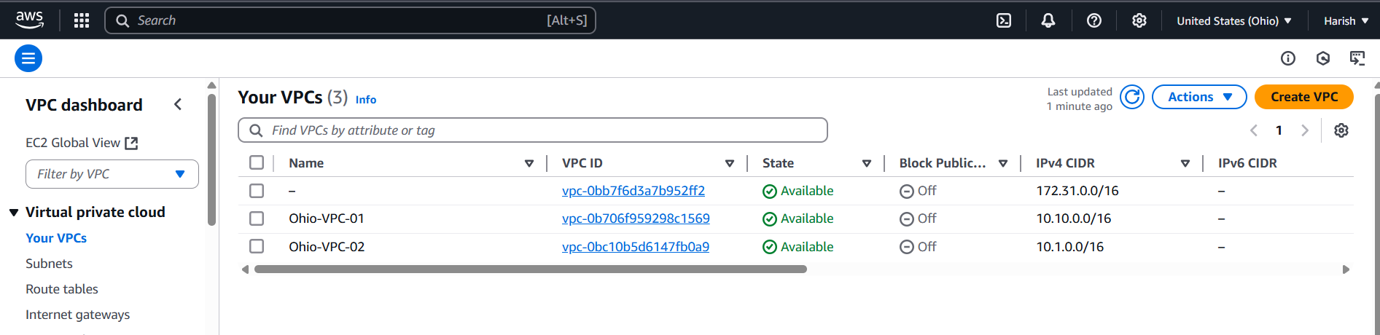
Fig: Two VPC are created in Ohio region.

Step2: Create one instance in each VPC of Ohio region.
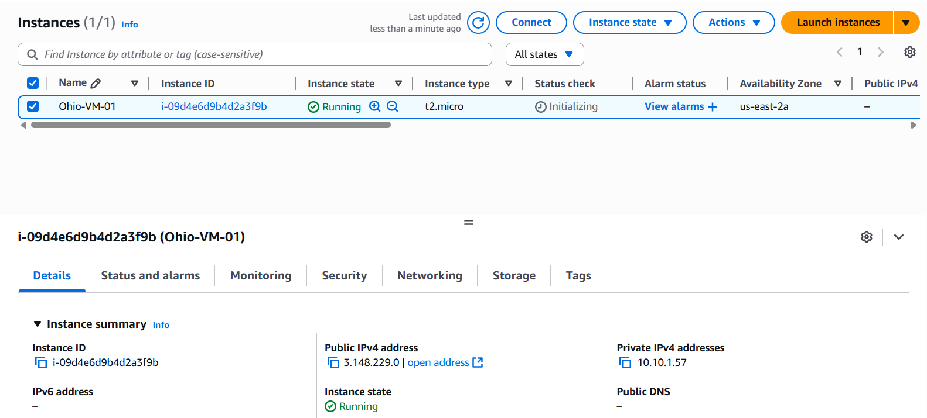
Fig: EC2 instance in Ohio region of VPC-01 (10.10.0.0/16).

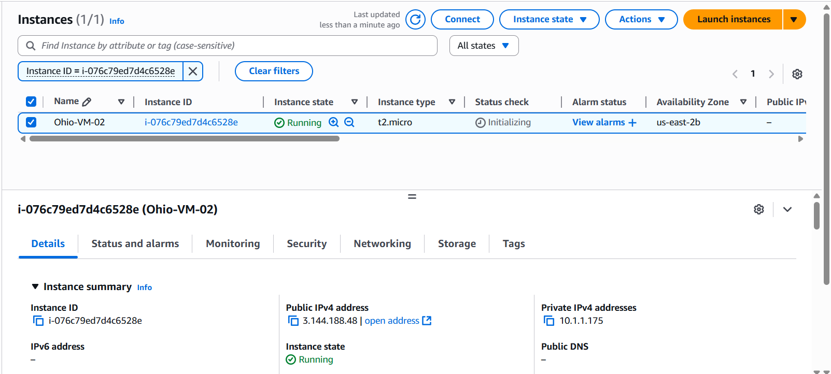
Fig: EC2 instance in the Ohio region of VPC-02 (10.1.0.0/16).

Note: These two instances cannot be communicate with each other because they are in two different VPC.

Similarly create two VPC in N. Virginia region and create one instance in each VPC.

Step3: Now create a Transit gate way and attach the VPC’s (Ohio-VPC-01 & Ohio-VPC-02) to it.
Go To VPC’s (global search)Transit gatewaysCreate transit gateway.
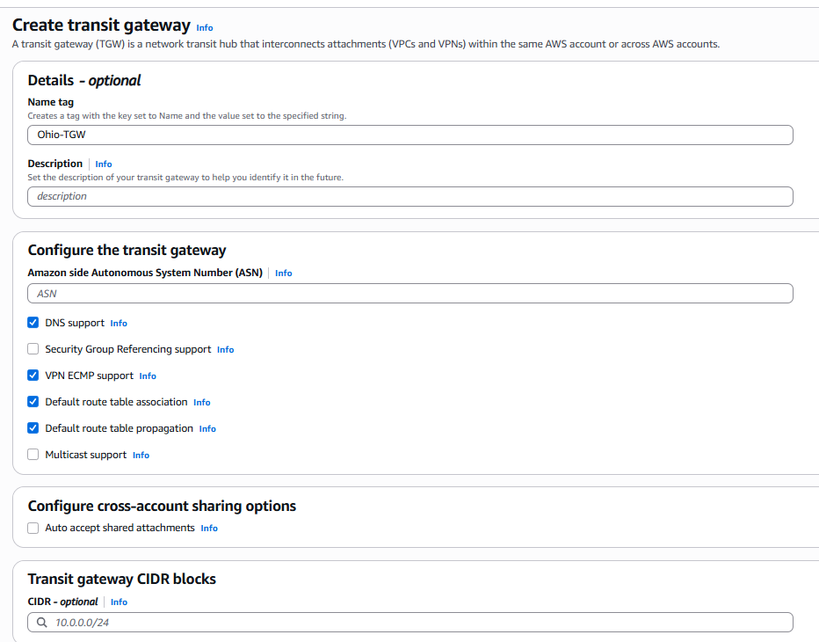
Fig: Transit gateway configuration.
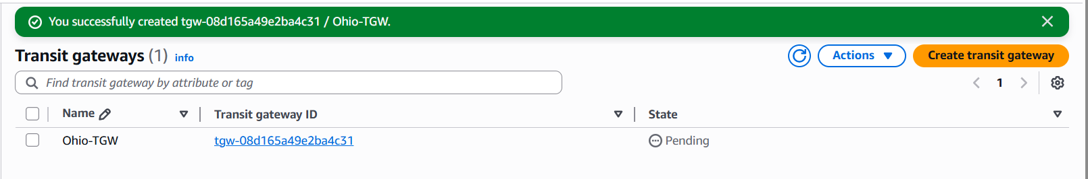
Fig: Transit gateway is created successfully.

Step4: Attach the VPC’s (Ohio-VPC-01 & Ohio-VPC-02) to the Transit gateway (Ohio-TGW).
Go To VPC’s (global search) Transit gateway attachments Create transit gateway attachment.
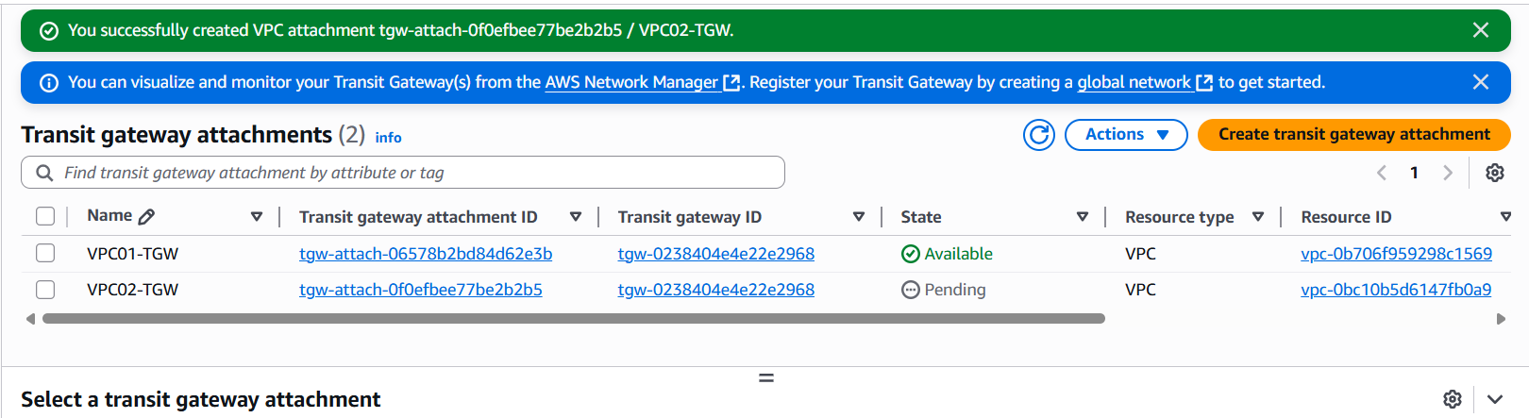
Fig: Two VPC’s are attached to the tansit gateway (Ohio-TGW).

Step5: Then configure the route tables of each VPC (Ohio-VPC-01 & Ohio-VPC-02), to use transit gateway to route the traffic.
Ohio-VPC-01: 10.10.0.0/16.
Ohio-VPC-02: 10.1.0.0/16
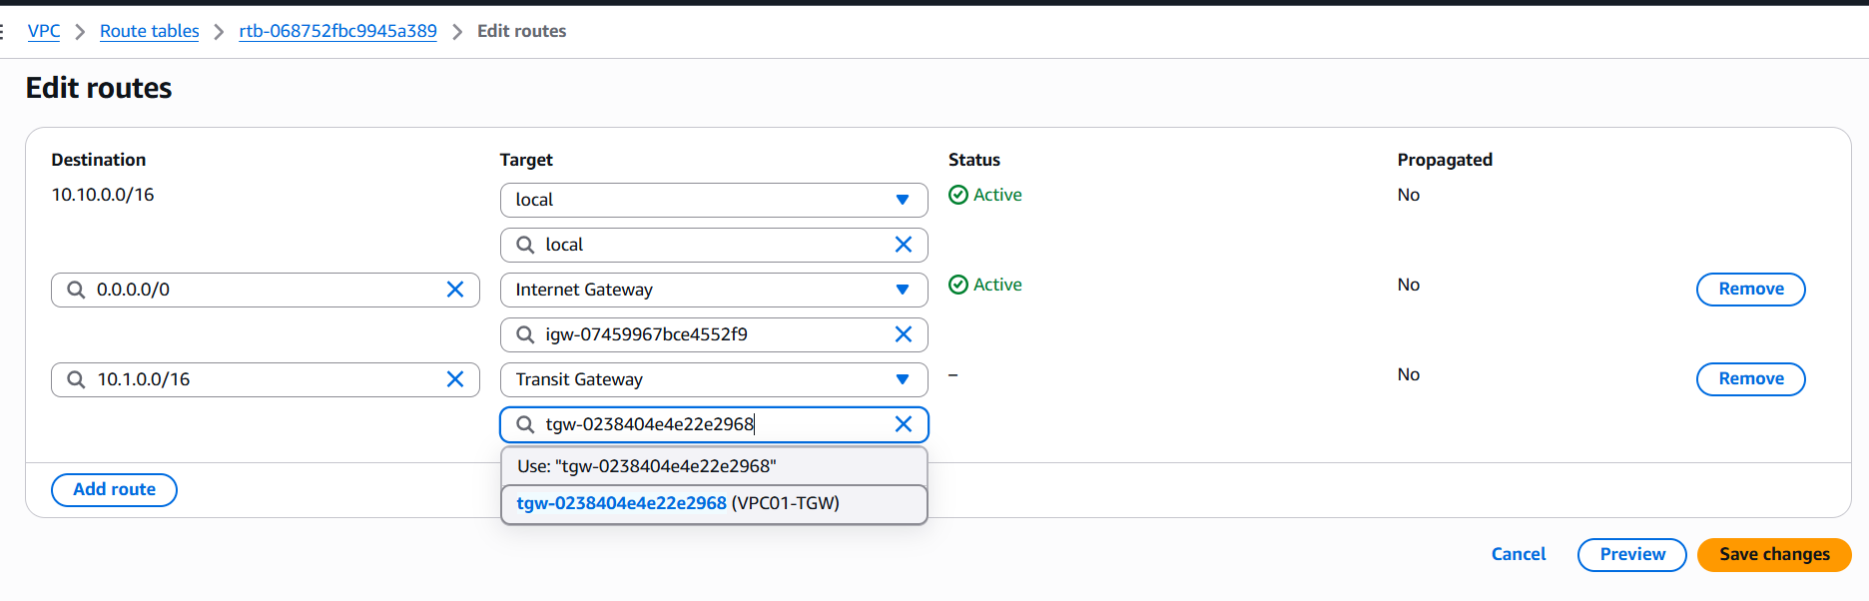
Fig: Route table of Ohio-VPC-01configuretion.

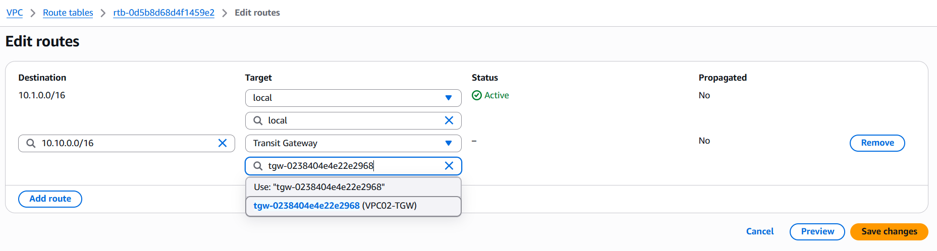
Fig: Route table of Ohio-VPC-02 configuration.

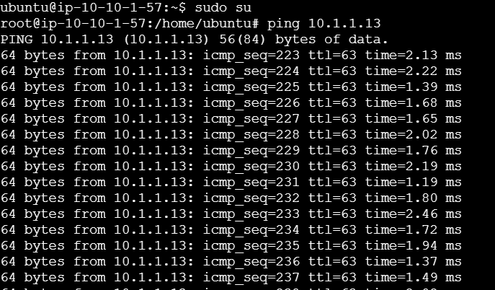
Fig: Pining of instance -02 (10.1.1.13) in instance-01
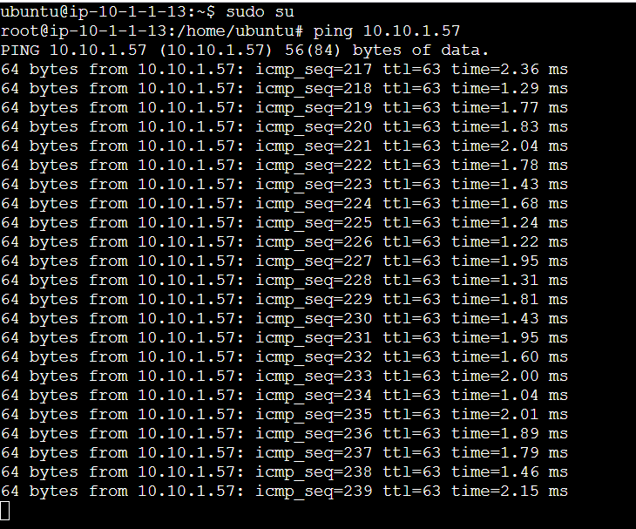
Fig: Pining of instance-01 (10.10.1.57) in instance-02.
Both VPC’s are connected each other using transit gateway instead of using VPC peering in same region.
Similarly perform above task in another region (N. Virginia).

Step6: Create two VPC in another region (N. Virginia).
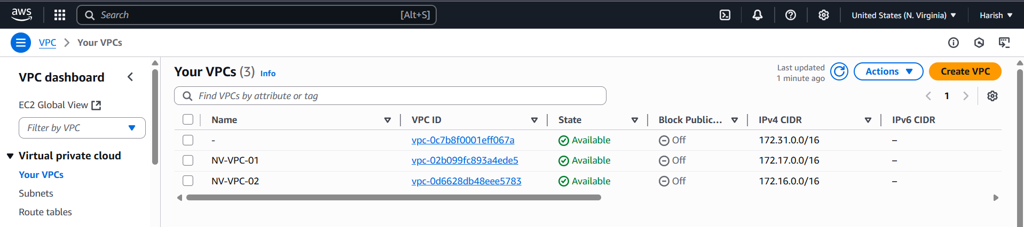
Fig: Two VPC are created in N. Virginia region.

Step7: Now create one EC2 instance in each VPC of N. Virginia region.
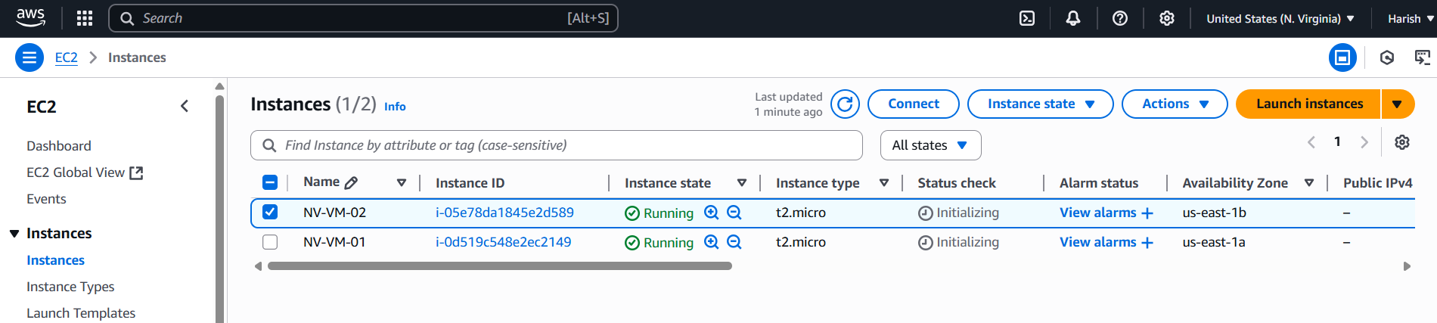
Fig: Two instances (NV-VM-01 & NV-VM-02) are created in N. Virginia region.

Step8: Create the transit gateway in N. Virginia and attach the VPC’s (NV-VPC-01 & NV-VPC-02) to it.
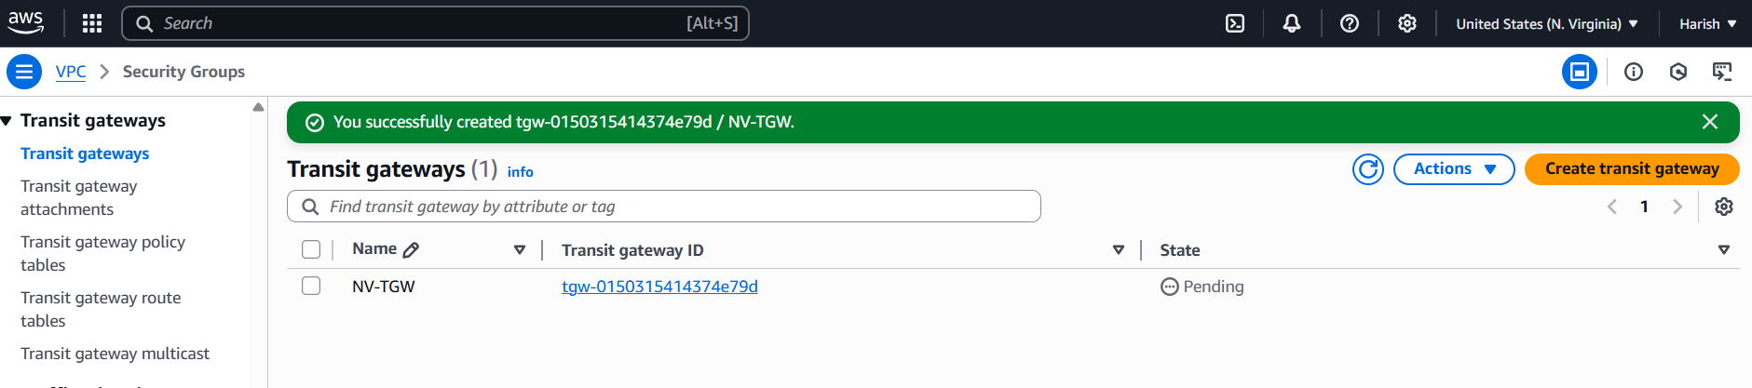
Fig: Transit gateway in N .Virginia region (NV-TGW).
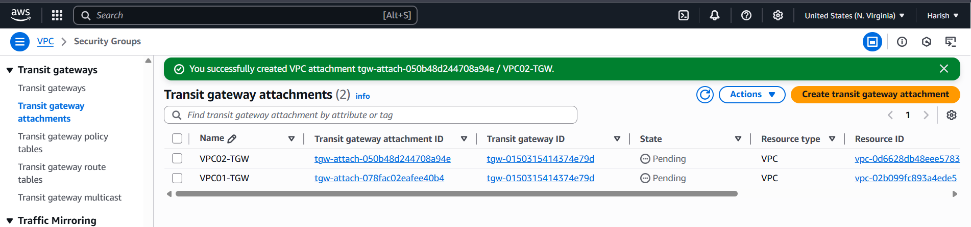
Fig: Two VPC’ (NV-VPC-01 & NV-VPC-02) are attached to the Transit gateway (NV-YGW).

Step9: Configure the Route tables of each VPC (NV-VPC-01 & NV-VPC-02) in N. Virginia to route the traffic using Transit gateway (NV-TGW).

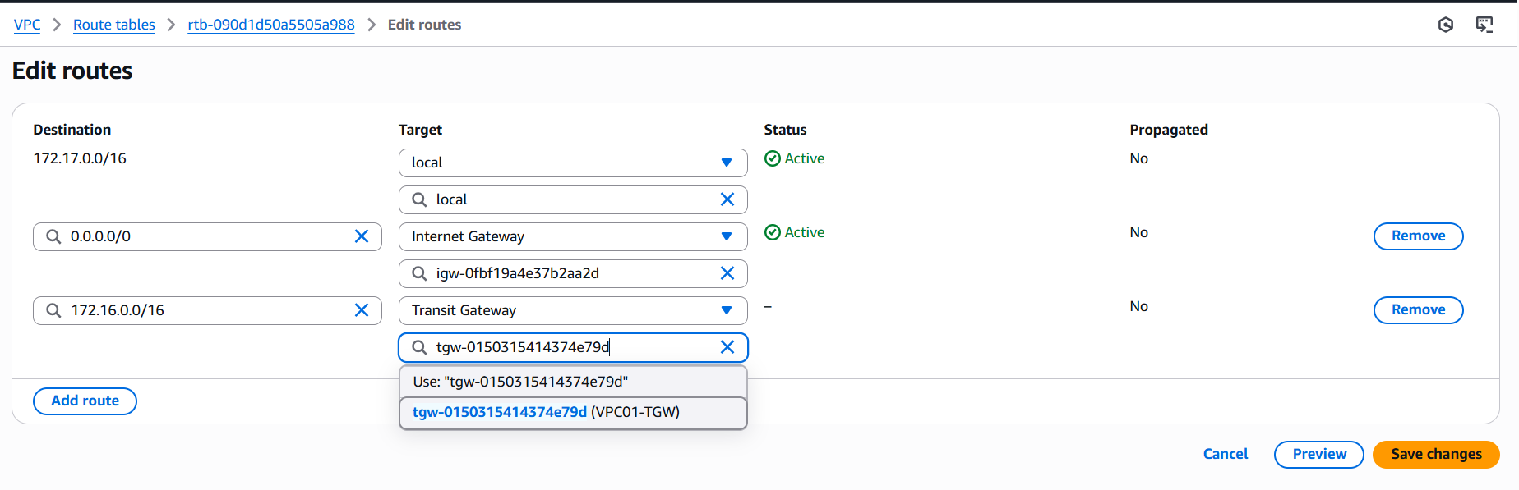
Fig: Configuring the route table in NV-VPC-01.

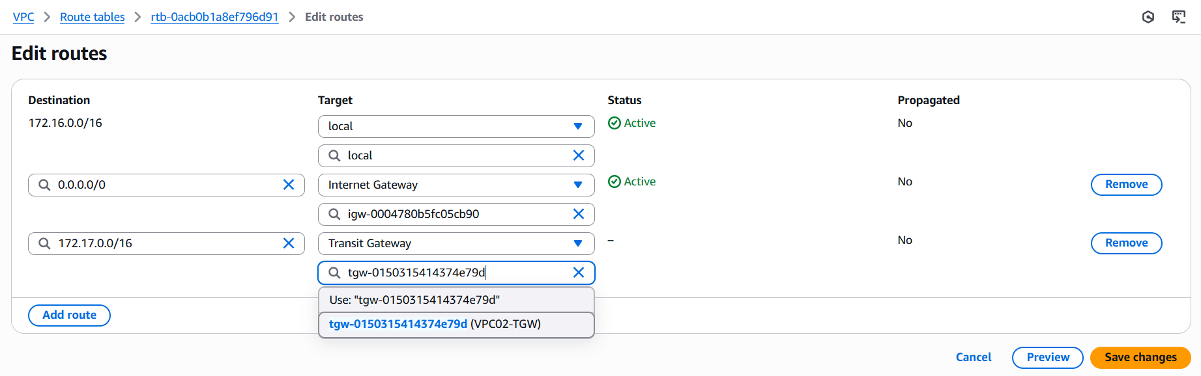
Fig: Configuring of route table in NV-VPC-02.

Now check whether both instances (NV-VM-01 & NV-VM-02) are pinging each other or not.
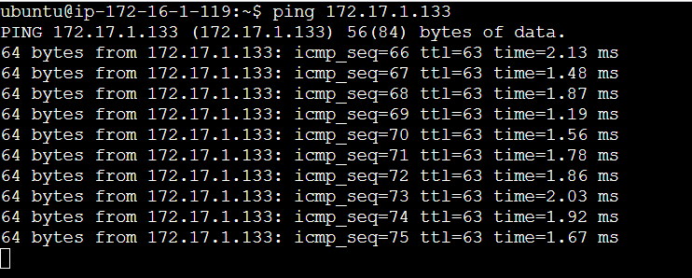
Fig: pining of NV-VM-01 (172.17.1.133) in NV-VM-02 (172.16.1.119).

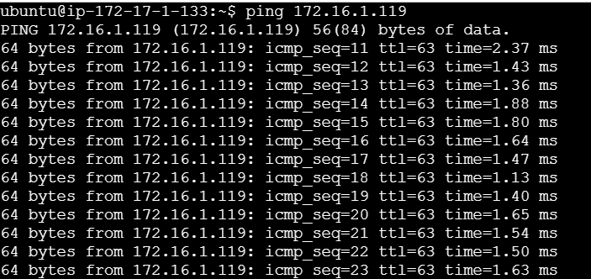
Fig: Pining of NV-VM-02 (172.16.1.119) in NV-VM-01 (172.17.1.133).

In N. Virginia region the two VPC’s (NV-VPC-01 & NV-VPC-02) are connect successfully using the transit gateway.

Establish connection/communication between two transit gateways in different regions:
Now perform the connection between two transit gateways (Ohio-TGW & NV-TGW) of different regions (Ohio & N. Virginia).
To establish communication between two AWS Transit Gateways (TGWs), you typically use Transit Gateway Peering. This allows resources in different AWS Regions (or the same Region) to communicate securely and efficiently.
To establish the connection between two transit gateways (TGW) we have to create and configure the
- Transit gateway attachment for peering connection,
- Transit gateway route table and
- By creating the static route within the Transit gateway route table.

Step1: Create the Transit gateway attachment for peering connection in a base region (Ohio).
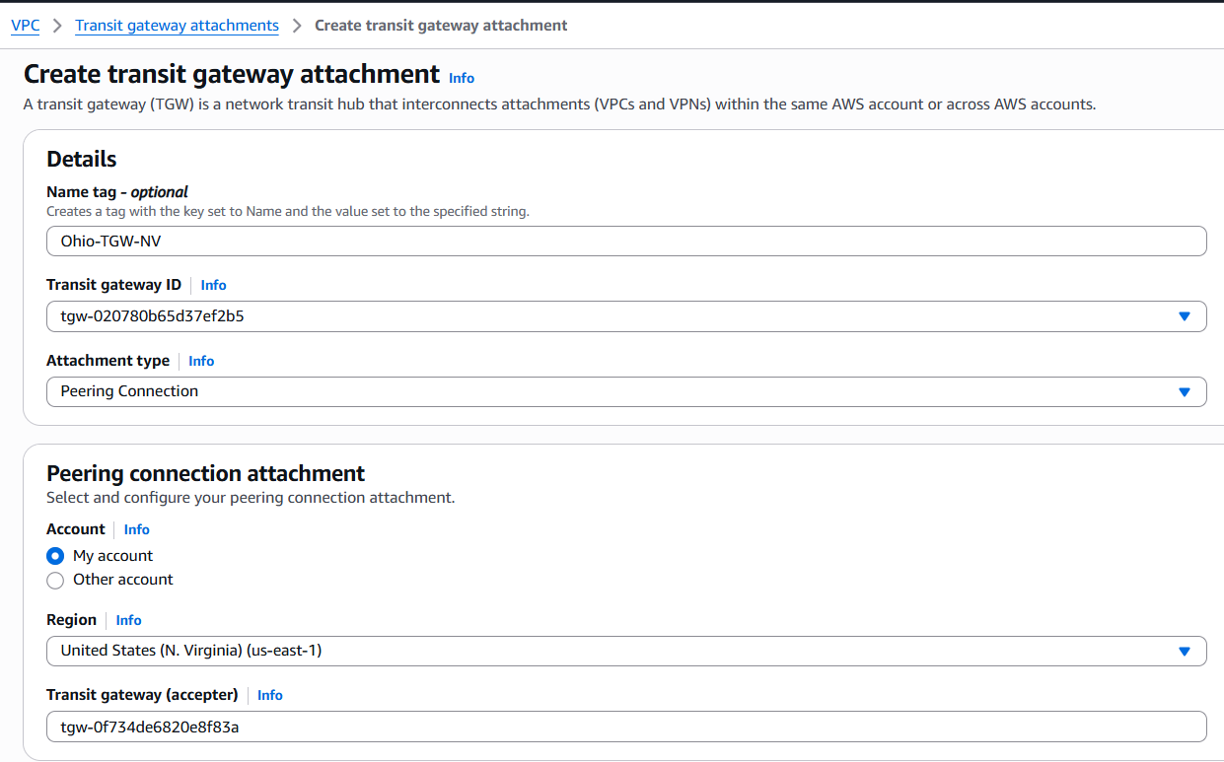
Ohio TGW ID
N. Virginia TGW ID
9Target region)

Fig: Configuring of TGW attachment for peering connection.

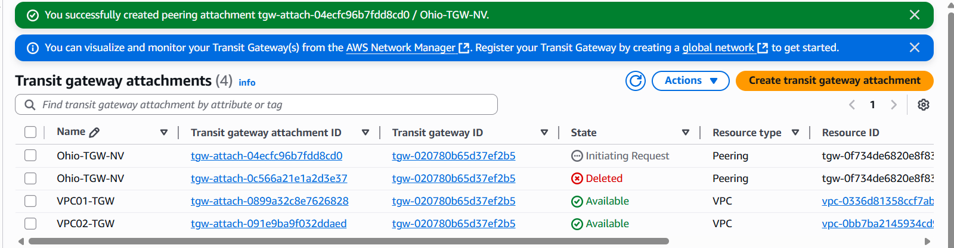
Fig: TGW attachment for peering connection created in Ohio region (base region).

Note: When we create a TGW attachment for peering connection in Ohio region (Base region) a request is send to the target region (N. Virginia). We have accept the attachment at the target region side as shown below figure.
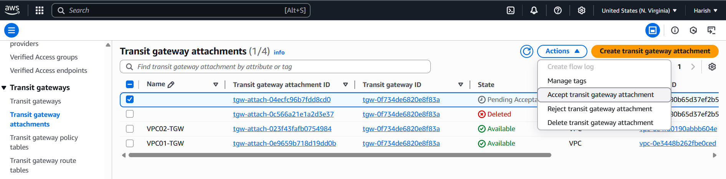
Fig: Accept the transit gate way attachment at target region side.

Note: While creating the transit gate way by default a transit gateway rote table is created.

Step2: Configure and create the static route within the default transit gateway route table. (Ohio region).
VPC Transit gateway route tablesselect default RTRoutesCreate static Route.
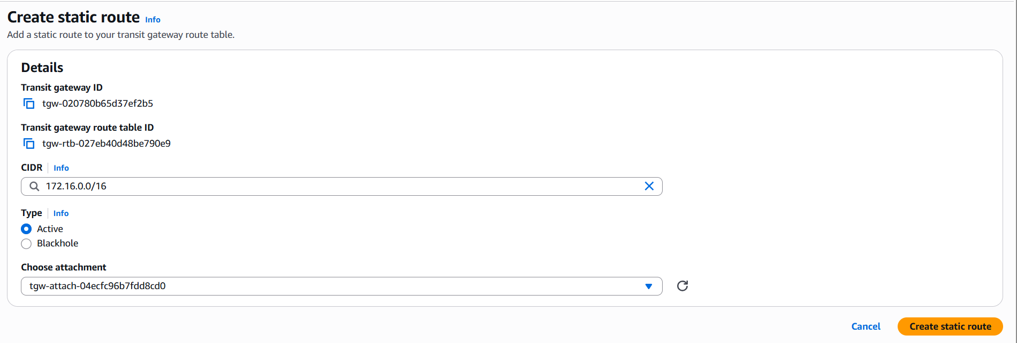
VPC CIDR number of target region (N. Virginia)
Transit gateway attachment for peering connection ID

Similarly create one more Static route for the target VPC CIDR number (172.17.0.0/16) in Ohio region (Base region).

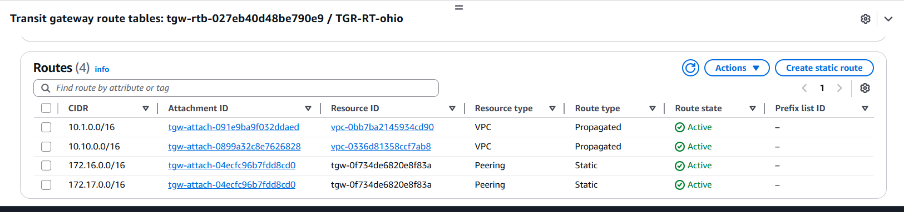
Fig: Transit gateway static routes in Ohio region.

And repeat the above thing (create static route) in another region target region (N. Virginia).
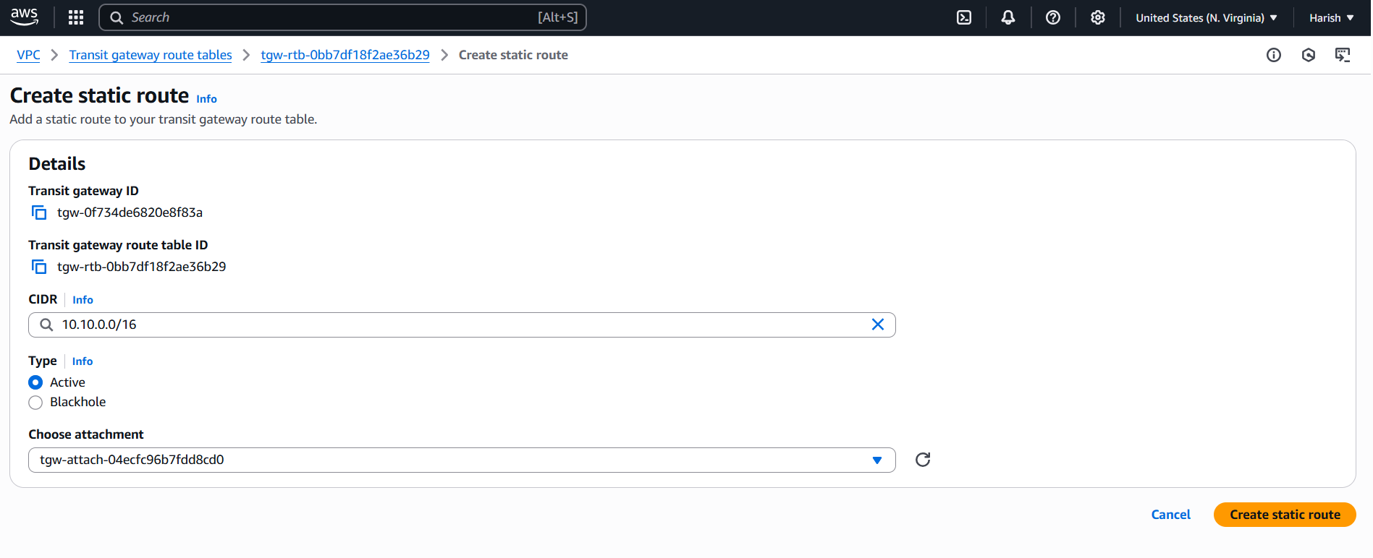
Transit gateway attachment for peering connection ID.
VPC CIDR number of remote
(Ohio region)

Similarly create the static route for another VPC CIDR number (10.1.0.0/16) of Ohio region.
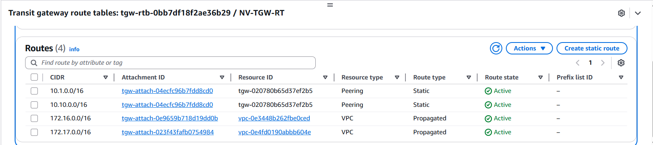
Fig: Static route in the N. Virginia.

Step3: Now configure the Route tables of each VPC in both regions (Ohio & N. Virginia) such a way the traffic routes using the Transit gateways.
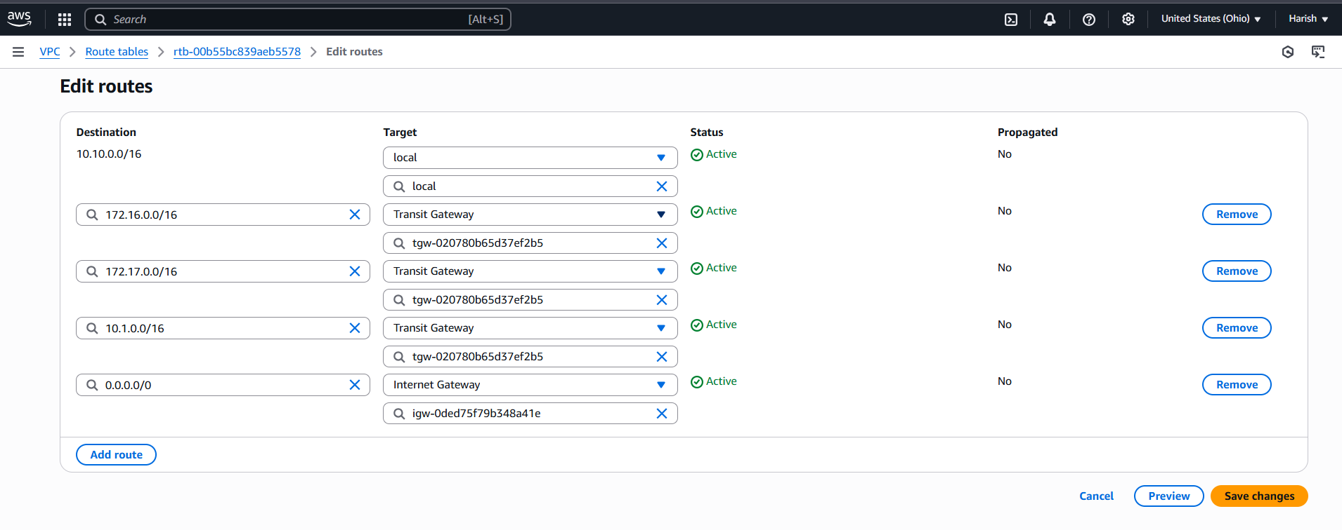
Fig: Configuring of route tables in Ohio region.

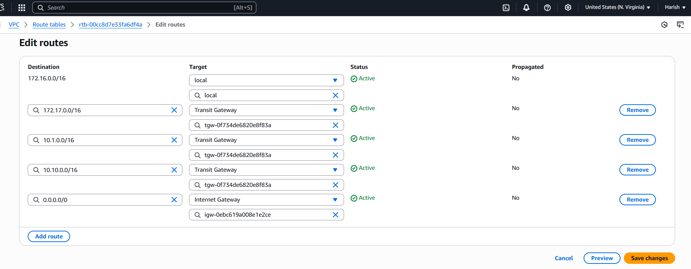
Fig: Configuring of route tables in N. Virginia region.

Step4: Now ping the instance in VPC of Region Ohio with the instance in the region N. Virginia.
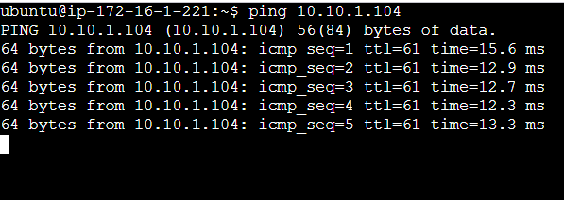
Fig: Pinging is done successfully between the instances of different regions.

